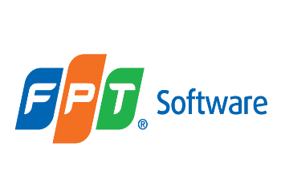

***Entity Framework Core***

**Training Assignment**

|  |  |
| --- | --- |
| Document Code | 25e-BM/HR/HDCV/FSOFT |
| Version | 1.1 |
| Effective Date | 20/11/2012 |

**Hanoi, 09/2019**

RECORD OF CHANGES

|  |  |  |  |  |  |
| --- | --- | --- | --- | --- | --- |
| No | Effective Date | Change Description | Reason | Reviewer | Approver |
| 1 | 25/09/2019 | Create assignments |  | TuTB | VinhNV |
|  |  |  |  |  |  |
|  |  |  |  |  |  |
|  |  |  |  |  |  |
|  |  |  |  |  |  |
|  |  |  |  |  |  |
|  |  |  |  |  |  |
|  |  |  |  |  |  |
|  |  |  |  |  |  |
|  |  |  |  |  |  |

Contents

Technologies 4

Working Environment 4

Database Relationship 4

Assignment_01 **Error! Bookmark not defined.**

Create solution and setup environment **Error! Bookmark not defined.**

Assignment_02 **Error! Bookmark not defined.**

Create models **Error! Bookmark not defined.**

Assignment_03 **Error! Bookmark not defined.**

Create context **Error! Bookmark not defined.**

Assignment_04 **Error! Bookmark not defined.**

Configure Fluent API for the Many-To-Many relationship **Error! Bookmark not defined.**

Assignment_05 **Error! Bookmark not defined.**

Setup Database Initialization Strategy **Error! Bookmark not defined.**

Assignment_06 **Error! Bookmark not defined.**

Create repositories **Error! Bookmark not defined.**

Assignment_07 **Error! Bookmark not defined.**

Unit Test **Error! Bookmark not defined.**

Assignment_08 **Error! Bookmark not defined.**

Code-first migration **Error! Bookmark not defined.**

|  |  |
| --- | --- |
|  | **CODE: NEFW.A.L001**  **TYPE: Long**  **LOC: NA**  **DURATION: Complete in 3 days** |

**Purpose of Assignments**

Use Entity Framework Core to manage a simple bookstore.

## Technologies

* Entity Framework Core
* MS .Net 6.0
* MS C# 10
* Linq
* Repository Design pattern.

## Working Environment

* MS SQL Server 2018,
* Visual Studio 2022,

## Database Relationship

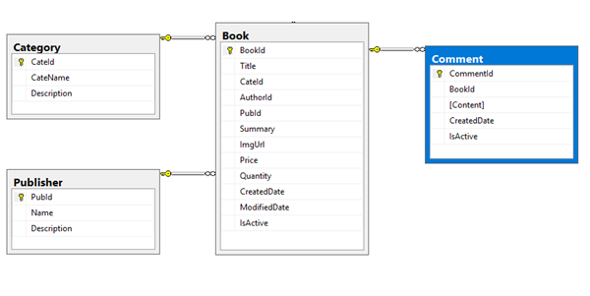

In this series of assingments, student will use technical points in Entity Framework Core to create, manage a database for the blog.

* Based on database design, create models and context to generate database
* Create repositories to manipulate data
* Use migration to apply changes
* Create unit test project and test

*These assignments should be performed by individuals.*

# Assignment_01

## Create solution and setup environment

Create new blank solution named: **FA.BookStore**

Add new project type Class Library into the solution. Project name: FA.BookStore.Core

Install Entity Framework Core from Nuget

**Estimated time**: 10 minutes

# Assignment_02

## Create models

Add new folder named Models into the project.

Create model class for each object:

* Category
* Publisher
* Book

Configure Data Annotations Attributes or FluentAPI for each class/property

**Estimated time**: 1 hour

# Assignment_03

## Create context

Create **BookStoreContext** and add appropriate DbSet properties.

Create Seed data: create 3 records for each data table

**Estimated time**: 30 minutes

# Assignment_04

## Create repositories

Add new folder Repositories

Inside Repositories folder, create repository for each entity with methods

* Category
  + Find(int categoryId)
  + AddCategory
  + UpdateCategory
  + DeleteCategory
  + GetAllCategories
* Publisher
  + Find
  + AddPublisher
  + UpdatePublisher
  + DeletePublisher
  + GetAllPublisher
* Book
  + FindBook(int bookId)
  + AddBook
  + UpdateBook
  + DeleteBook
  + GetAllBook
  + FindBookByTitle(string title)
  + FindBookBySummary(string summary)
  + GetLatestBook(int size)
  + GetBooksByMonth(DateTime monthYear)
  + CountBooksForCategory(string category)
  + GetBooksByCategory(string category)
  + CountBooksForPublisher(string publisher)
  + GetBooksByPublisher(string publisher)

**Estimated time**: 3 hours

# Assignment_05

## Test

Create new project named FA.BookStore.Test using project template NUnit

Configure connection string for **BookStoreContext**

Create test case, test data

Run test and check result

**Estimated time**: 3 hours

# Assignment_06

## Code-first migration

Enable code-first migration for **BookStoreContext**

Add first migration and update database

Add new entity named **Comment**

Add DbSet for Comment entity

Add migration and update database

Add repository for Comment

* + Find(int commendId)
  + AddComment
  + UpdateComment
  + DeleteComment
  + GetAllComments
  + GetCommentByBook(string bookId)

Add new test case, test data

Run test case and check result

**Estimated time**: 3 hours

**-- THE END --**